README FILE

**To run the program :**run the : *main.py* file with the path to file you want to try.  
full command (it works this way on my machine) :   
python main.py PATH_TO_FILE

**Elaboration about the algorithm which I used to solve the problem:**

I started with the case of even-edge square board.  
I divided the game board to four parts :  
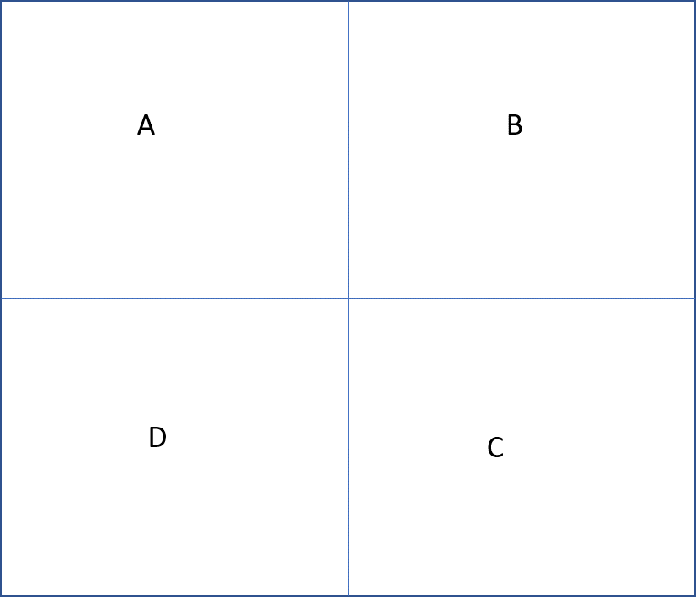

When I read the boxes and hunters coordinates I counted the number of boxes and hunters in each part, then I concluded the number of free seats in each part.  
Then, I use the follow equations :  
Fix for each part A,B,C,D $H_{A}-number of hunters in A$ $$B_{A}-number of boxes in A \\ F_{A}-number of free seats in A \left({\left(\frac{N}{2}\right)}^{2}-H_{A}-B_{A}\right) \\ X_{A}-the number of hunters can be added to part A \left(limited by F_{A}\right)$$

Now, according to the rules I get : $$X_{A}+H_{A}+X_{B}+H_{B}=X_{C}+H_{C}+X_{D}+H_{D} \\ X_{A}+H_{A}+X_{D}+H_{D}=X_{B}+X_{C}+H_{B}+H_{D} \\ 0<X_{part}<F_{part} \left(part∈\left\{A,B,C,D\right\}\right)$$ 
Then, I tried to find maximal X values such that : $X_{A}+X_{B}+X_{C}+X_{D}→max$

For the case of odd-edge game boards :   
I created different partition to the game board -

The idea is that the only difference between the even and odd game board is the row or column in the middle.  
So I set the row/column as a different part of the board ( $size of\frac{N-1}{2}*1)$ 
And then I have to balance the parts A,B,C,D like before and I have to balance E against G and H against F.  
The part I In the center is just the center point of the board (size 1*1).